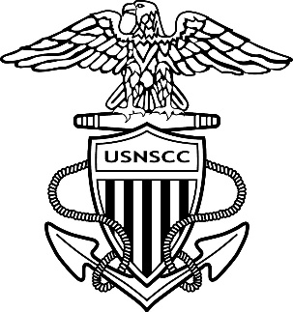
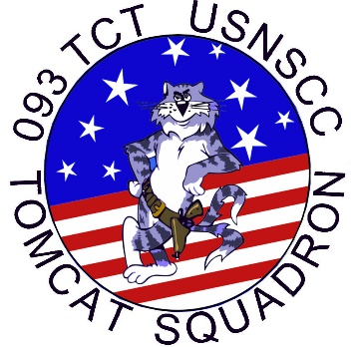
PLEASE JOIN US
AS WE CELEBRATE
THE ACHIEVEMENT OF
OUR
LEADING PETTY OFFICER,
PETTY OFFICER FIRST CLASS
OLIVIA G ORBAN
UNITED STATES SEA CADET CORPS
As she receives her
ANCHORS & ADVANCEMENT
To the rank of
CHIEF PETTY OFFICER

Saturday, February 11, 2023
Chief Pinning Ceremony will begin promptly at 11:00 AM
American Legion, Post 4
401 N Groesbeck Highway
​Mount Clemens, MI 48043
​
Attire: Business Casual
Refreshments served after

RSVP: LTJG Kimberly Perkins
tao.093cat@seacadets.org
586-839-8449

Reminder for USNSCC cadets only: your Report time is 1000 at Post 4, no later

